**Garage Management system**

**Project Title :**  Garage Management system

**College :** Kg College of arts and science

**Team ID :** NM2025TMID23758

**Team Size :**  4

**Team Member Details:**

1. **Team Leader**  : Sanjay Sam

**Email** : 2326ka45@kgcas.com

1. **Team Member**  : Sanjay M

**Email**  : 2326ka46@kgcas.com

1. **Team Member**  : Sean Sefika

**Email**  : 2326ka47@kgcas.com

1. **Team Member**  : Shahataj Z

**Email**  : 2326ka48@kgcas.com

**INTRODUCTION:**

* 1. **Project Overview**

The Garage Management System is a valuable tool for automotive repair facilities, helping them deliver top-notch service, increase operational efficiency, and build lasting customer relationships. With its user-friendly interface and powerful features, GMS empowers garages to thrive in a competitive market while ensuring a seamless and satisfying experience for both customers and staff.

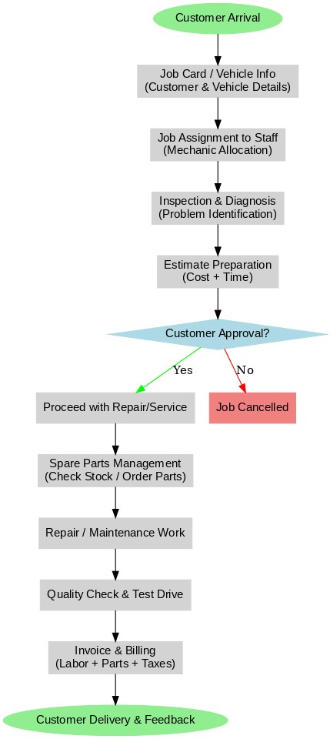

* 1. **Purpose**

The purpose of the Garage Management System is to streamline and automate the daily operations of automotive repair facilities. It provides a centralized platform for managing customer details, vehicle information, job assignments, repair workflows, spare parts inventory, billing, and customer feedback. By digitizing these processes, GMS enhances operational efficiency, reduces errors, ensures timely service delivery, and improves customer satisfaction. Ultimately, it empowers garages to deliver high-quality service, maintain better resource utilization, and thrive in a competitive automotive service industry.

# DEVELOPMENT PHASE

**Creating Developer Account:**

By using this URL: <https://developer.salesforce.com/signup>

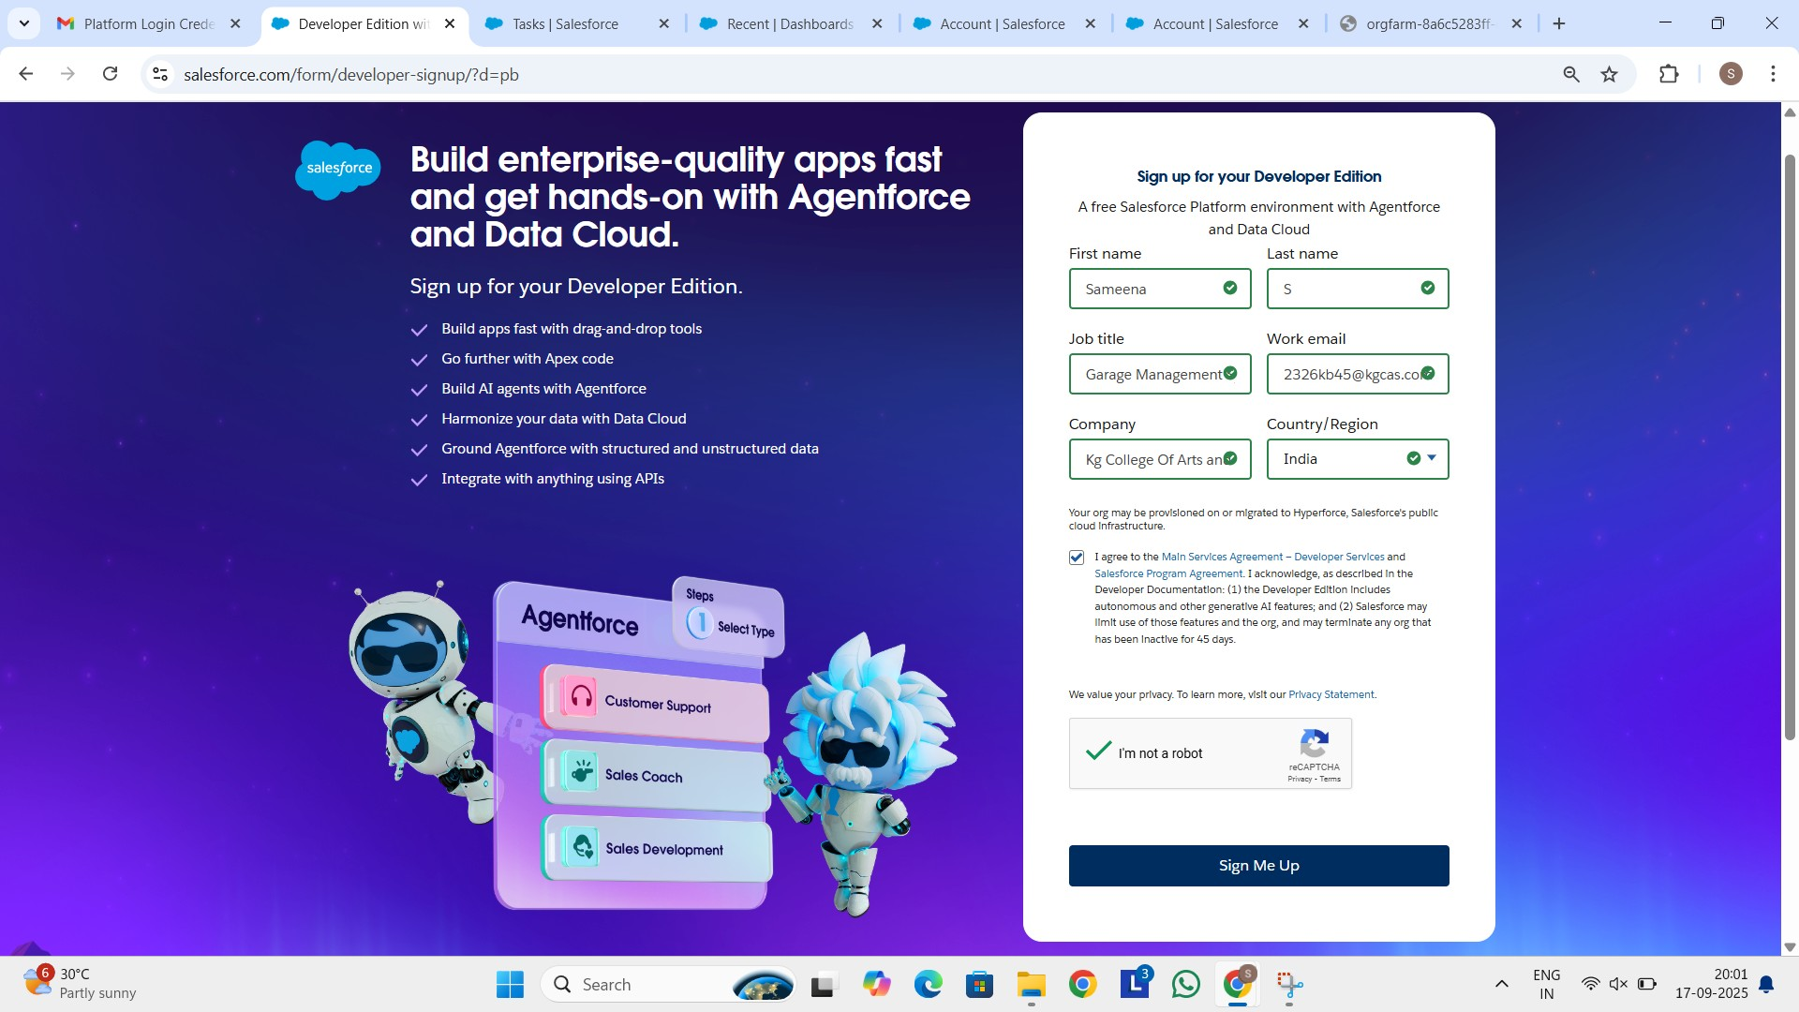

Created objects:

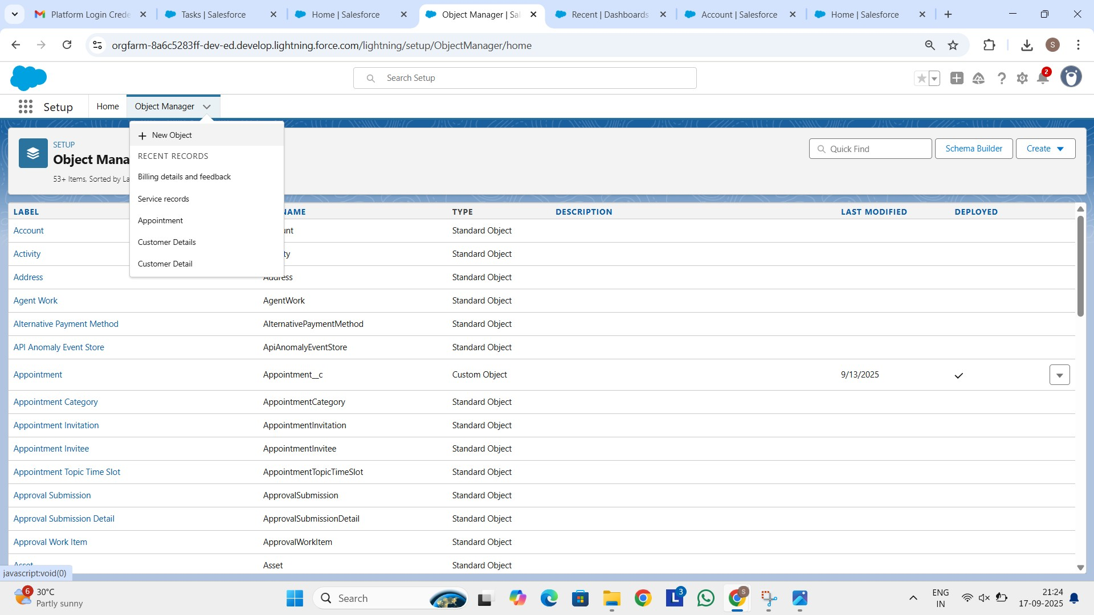

Billing details and feedback:

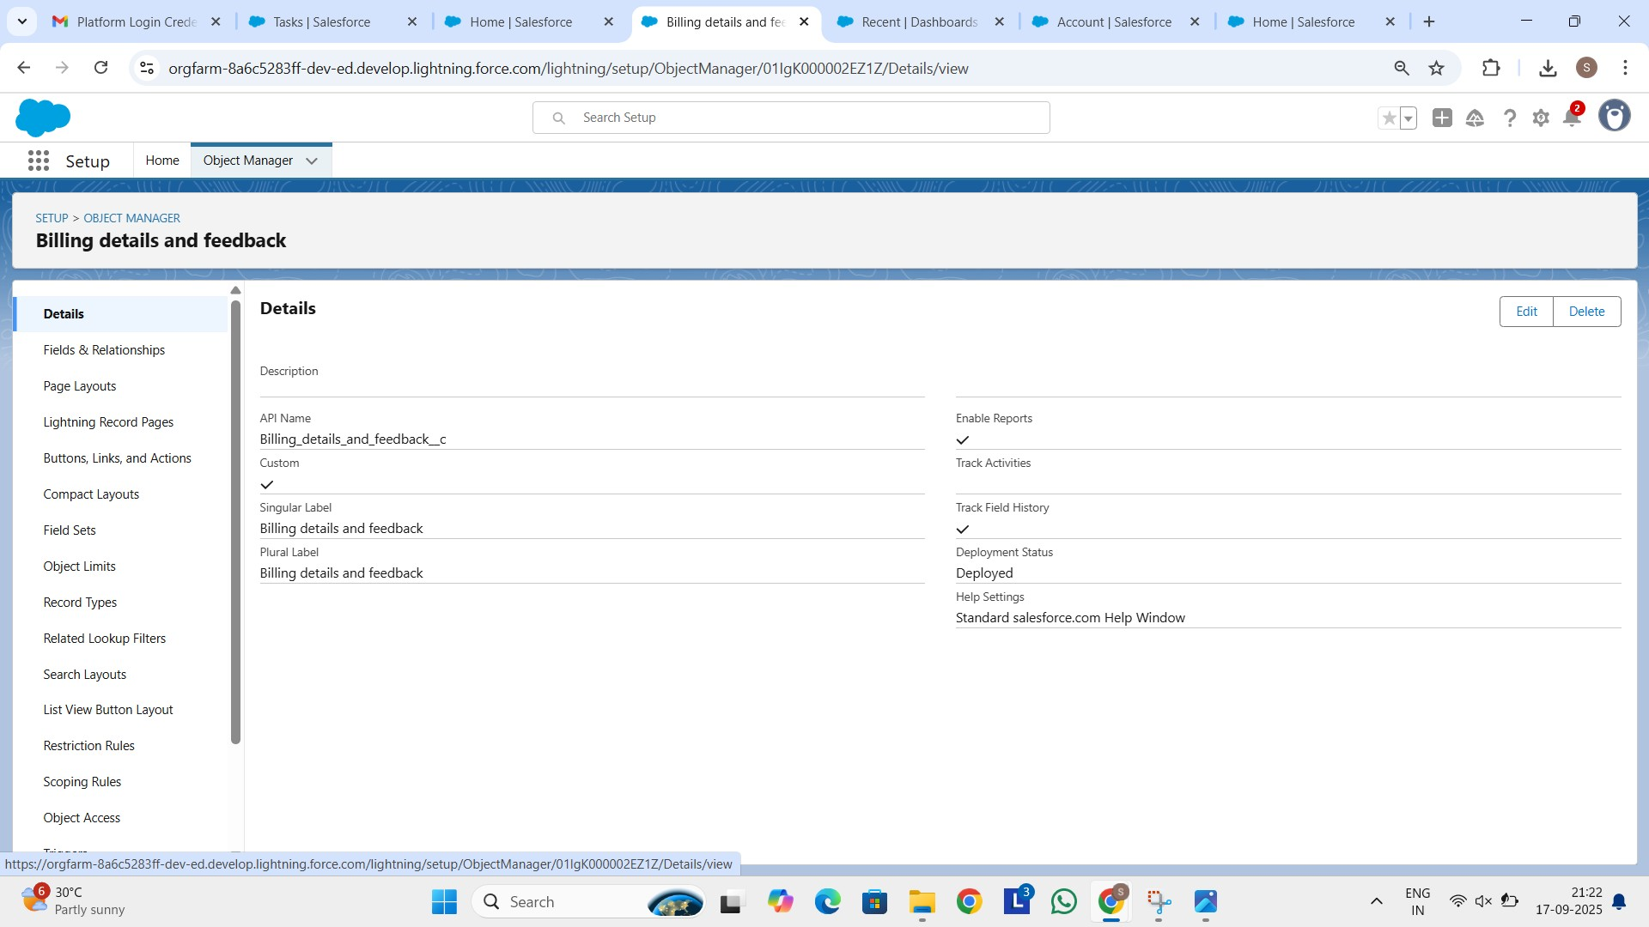

Service records:

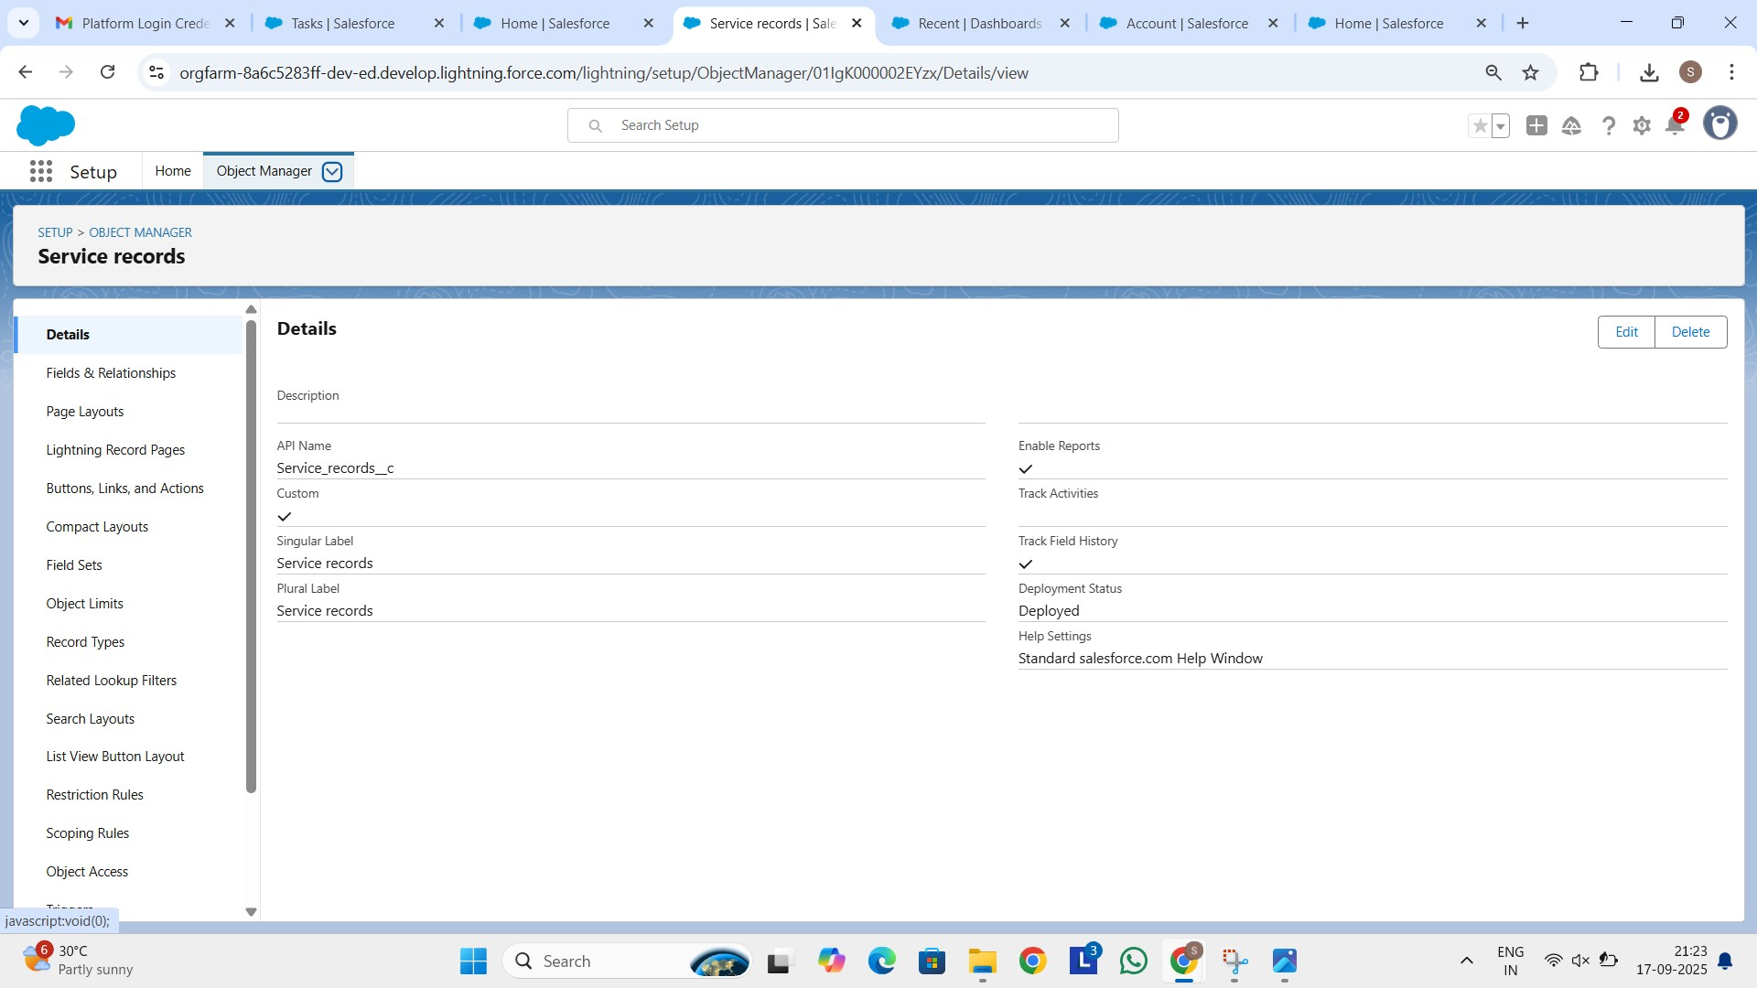

Appointment:

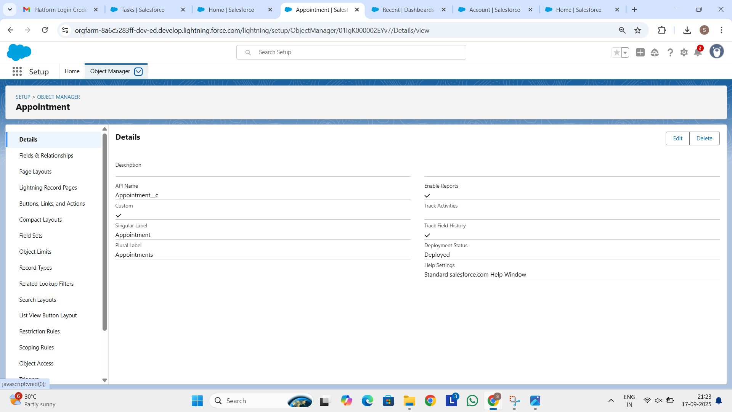

Customer Details:

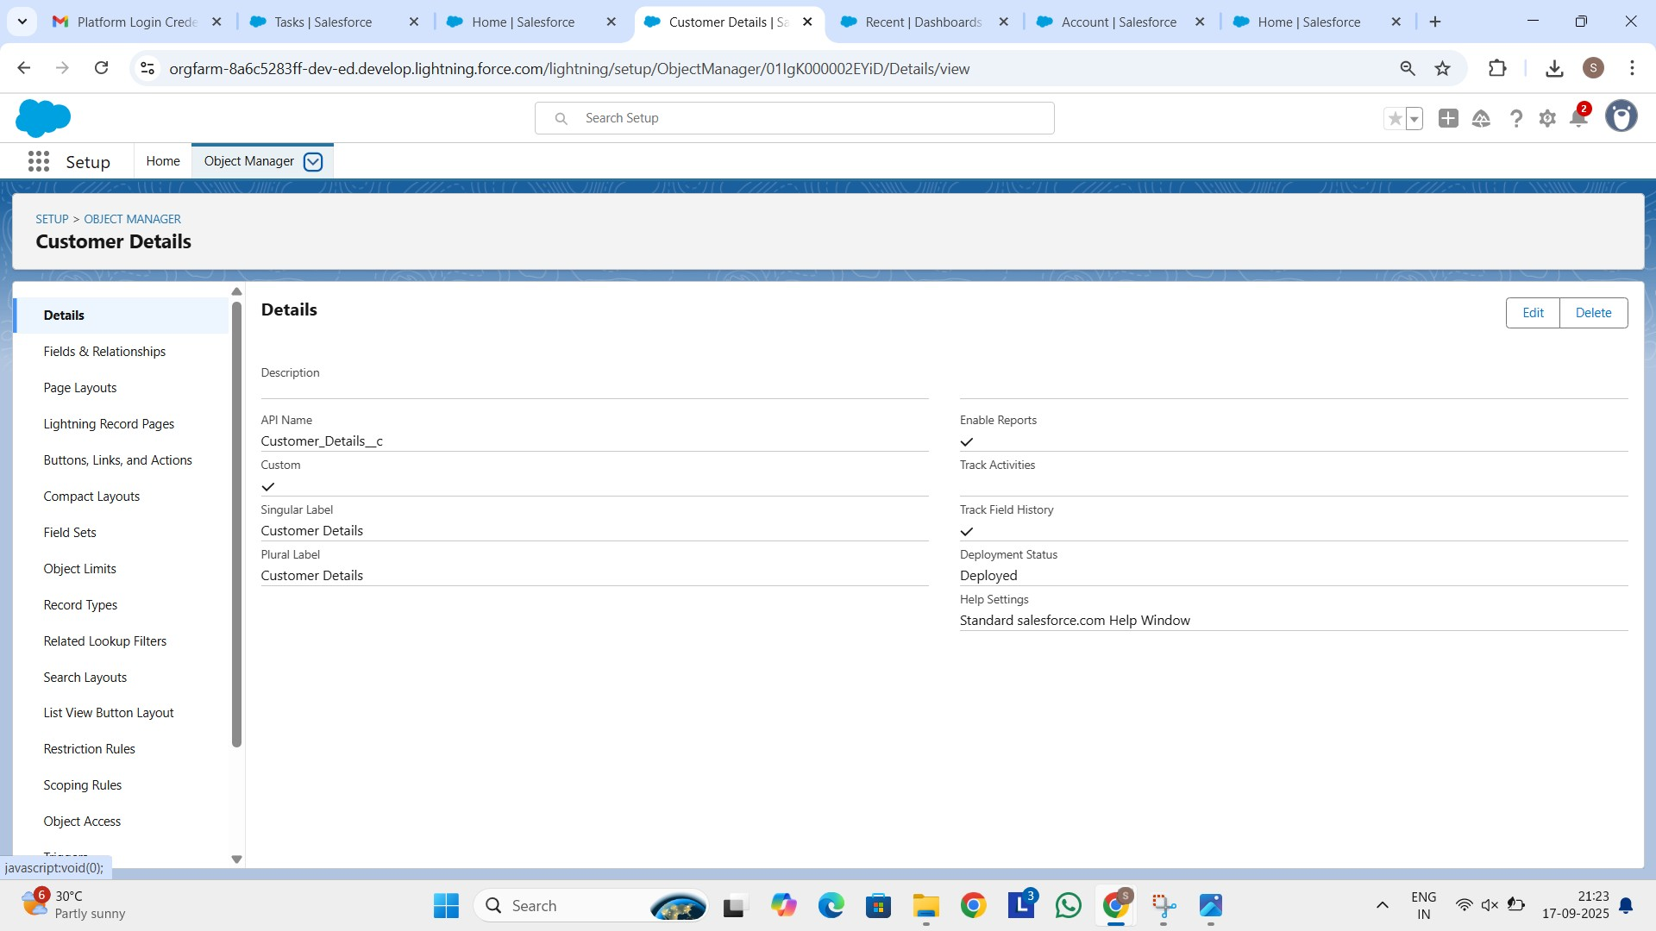

Configured fields and relationship:

Billing details and feedback:

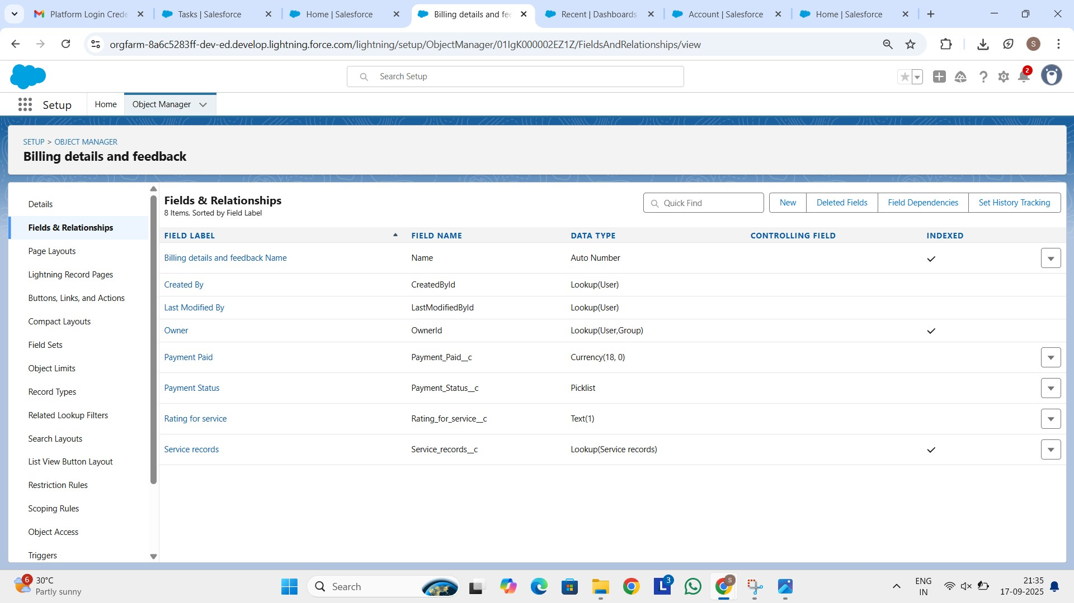

Service records:

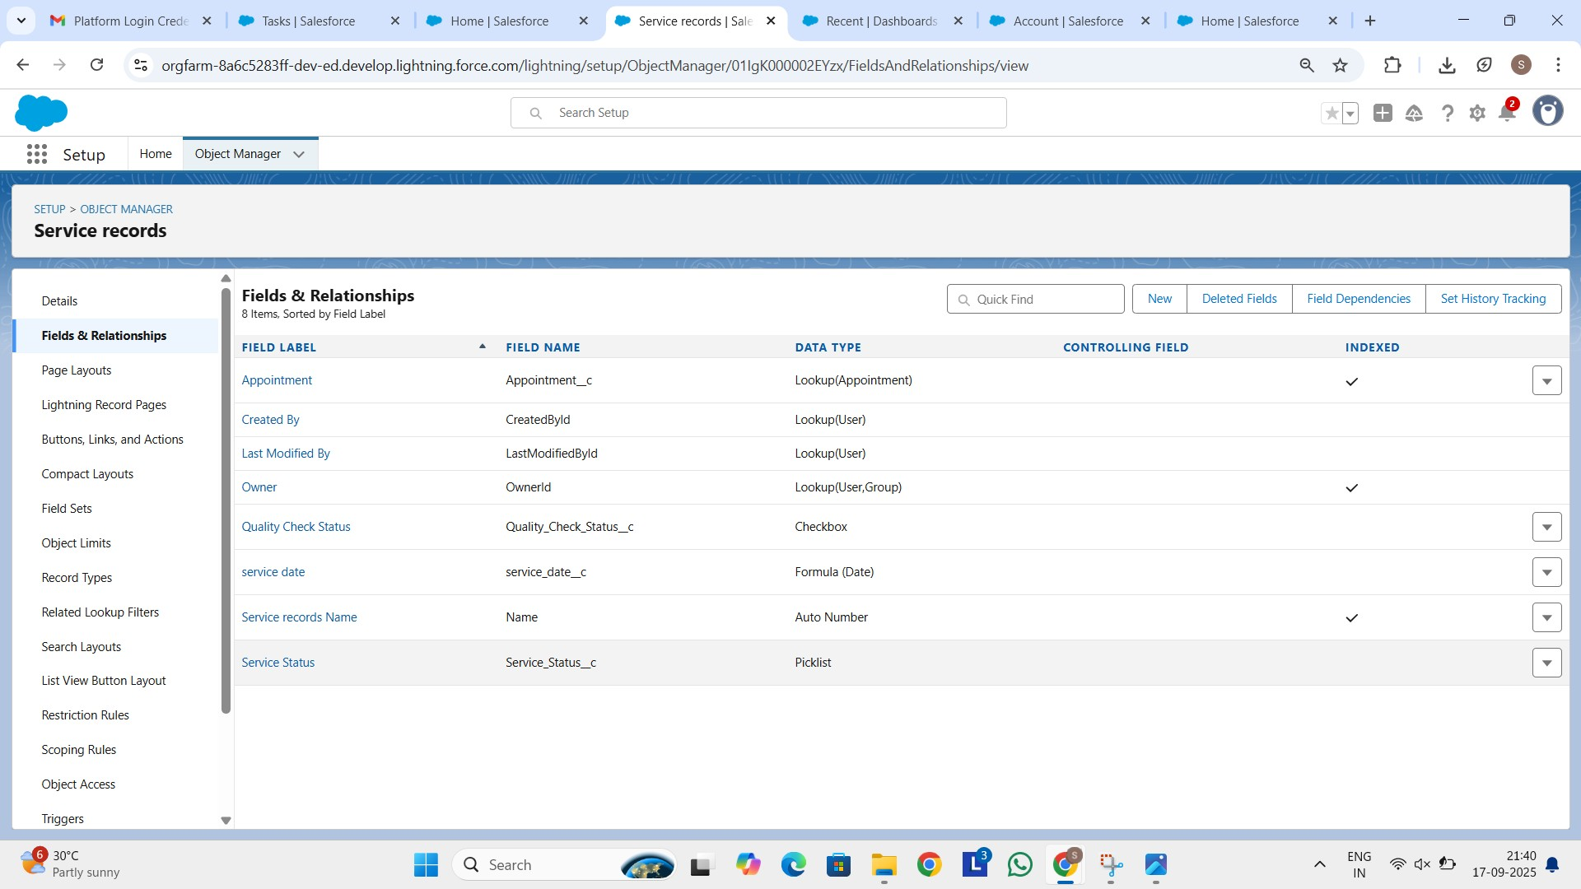

Appointment:

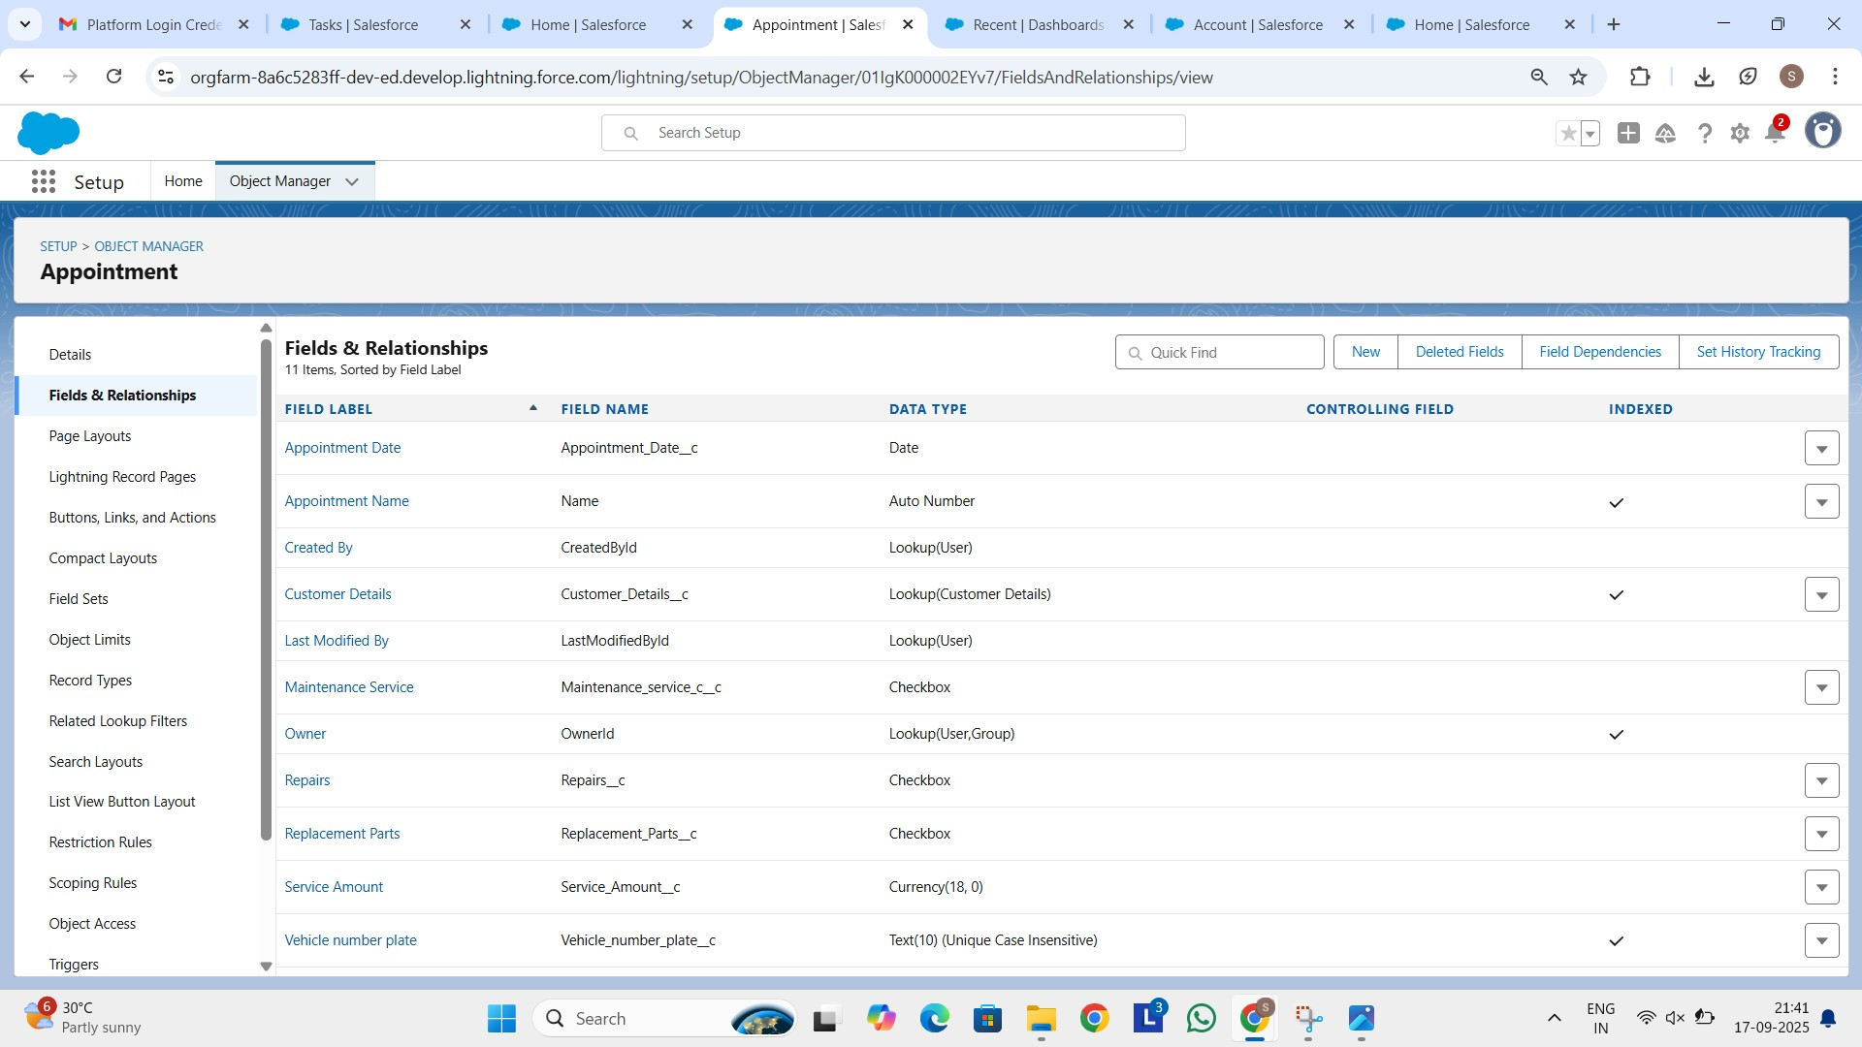

Customer Details:

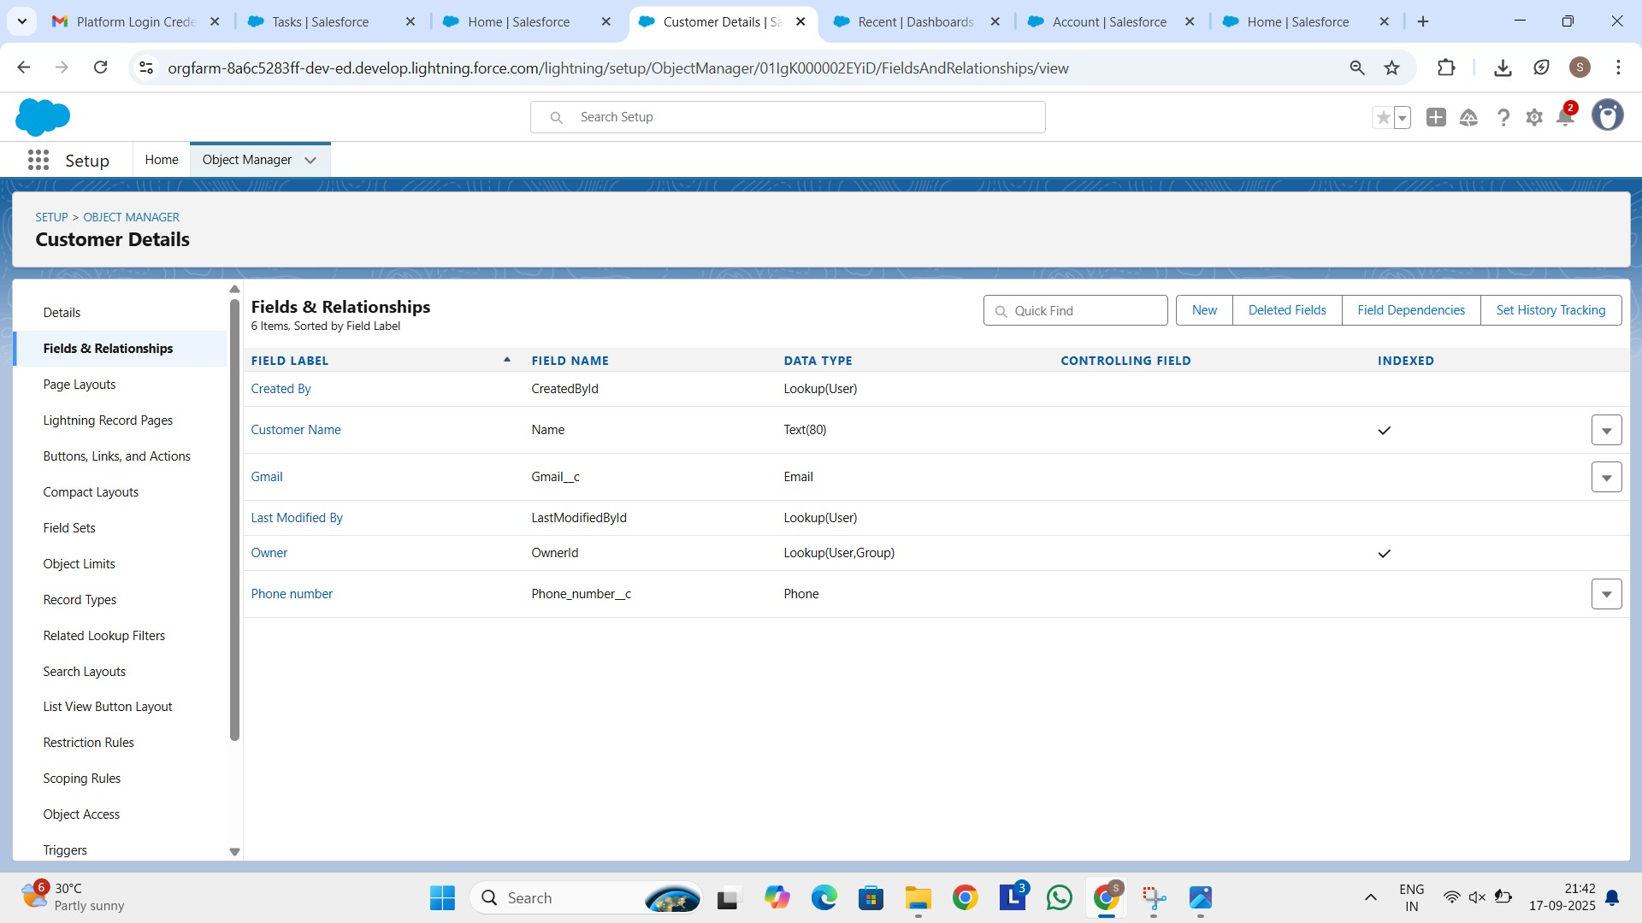

Developed Lightning App:

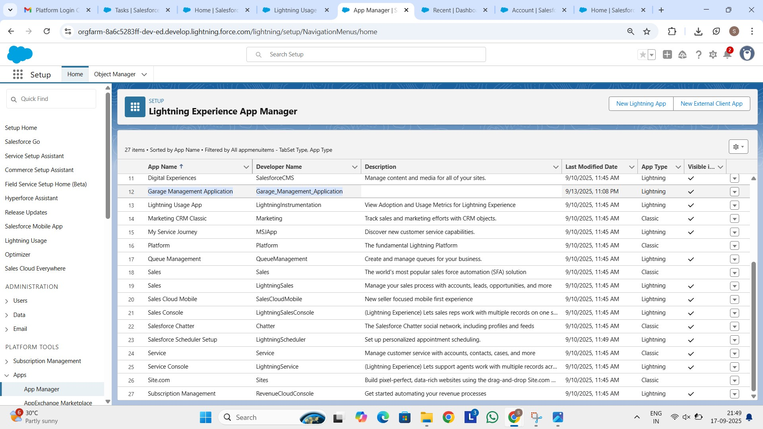

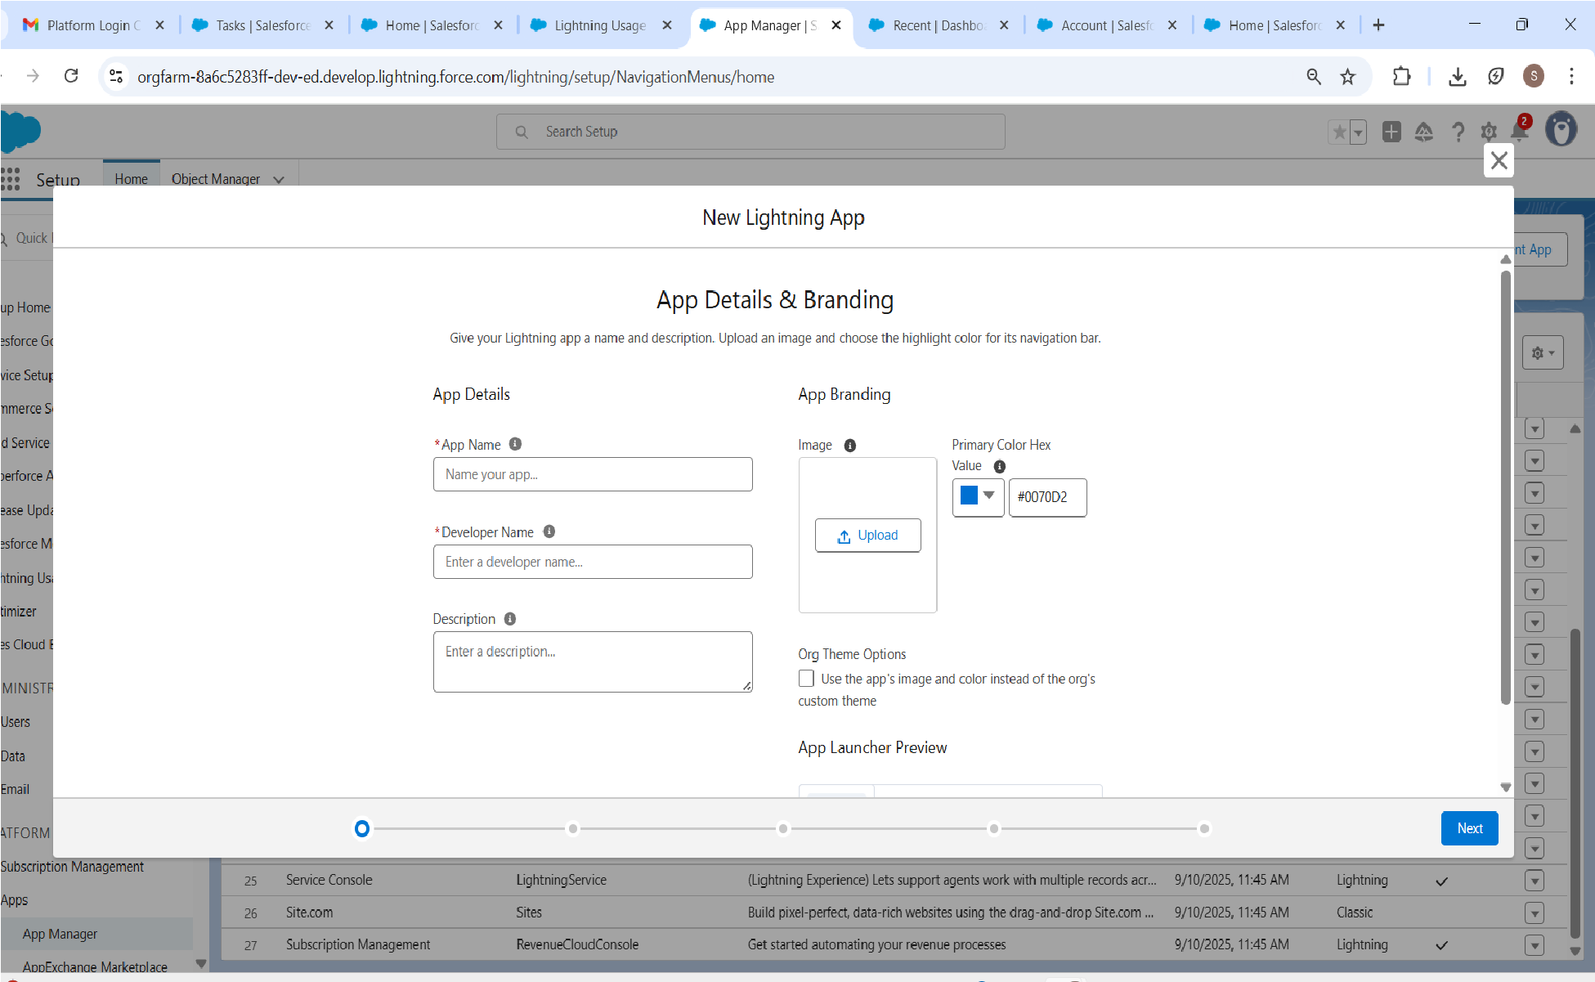

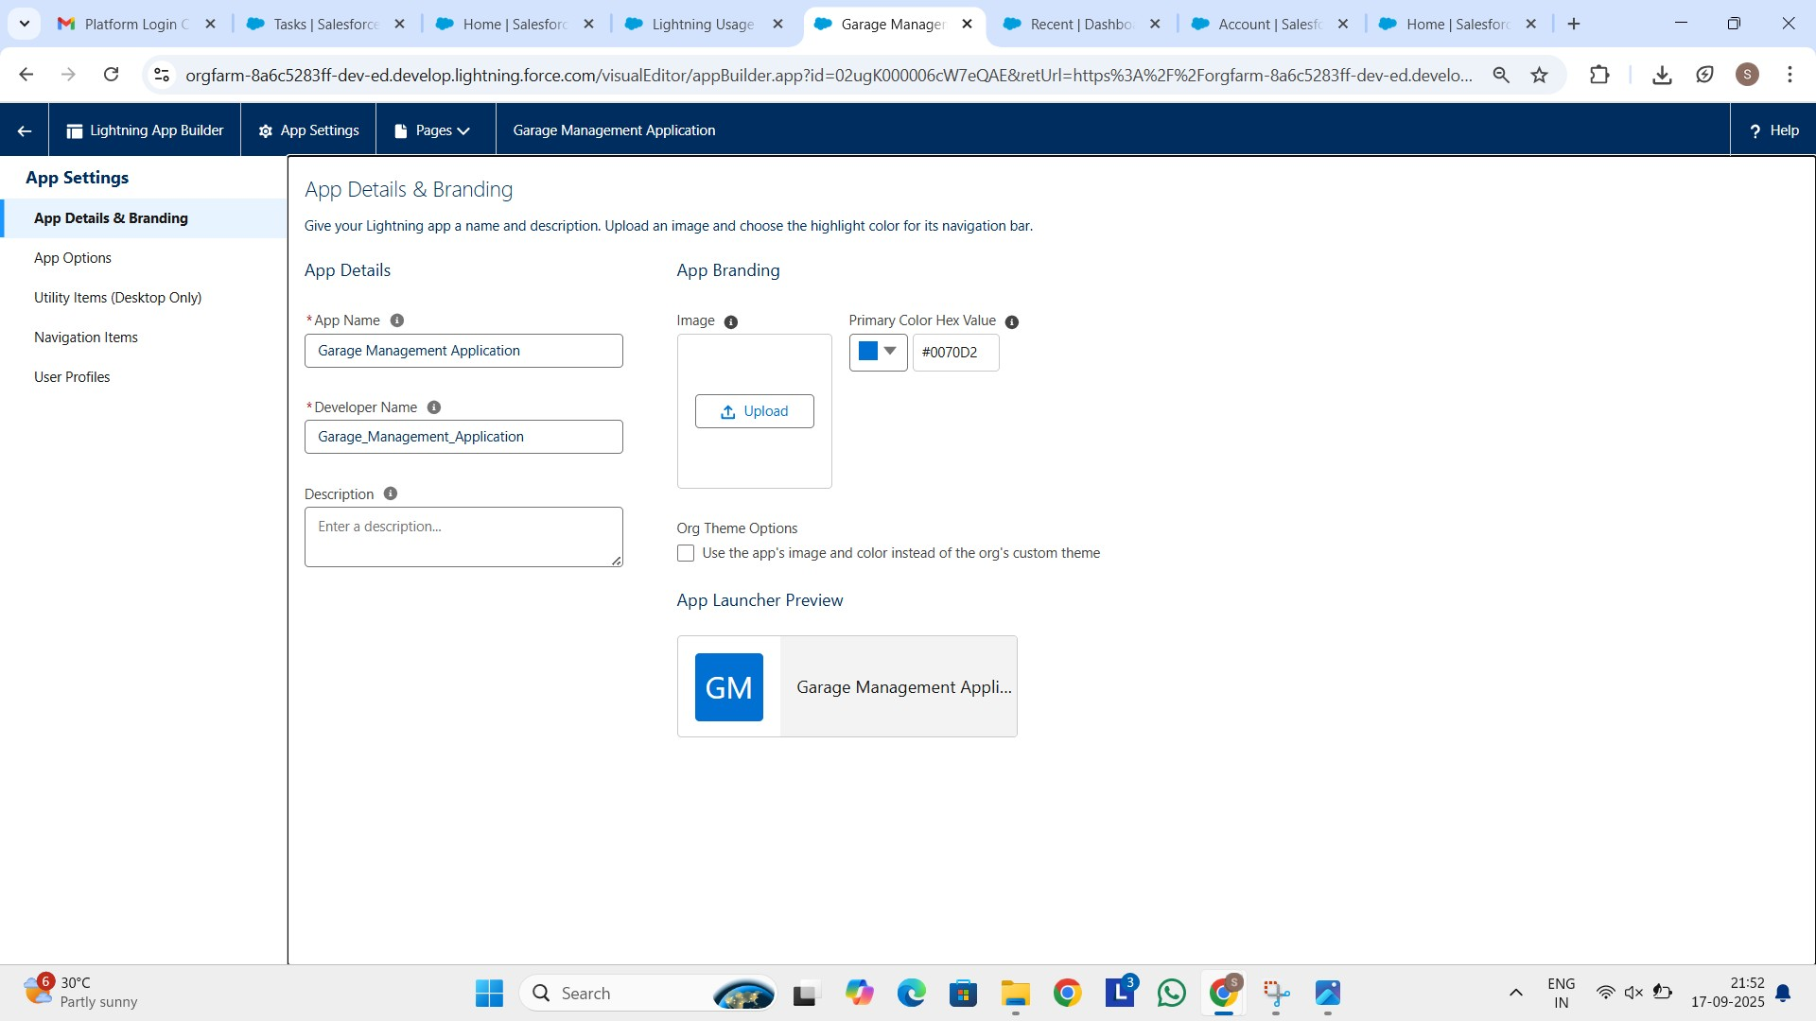

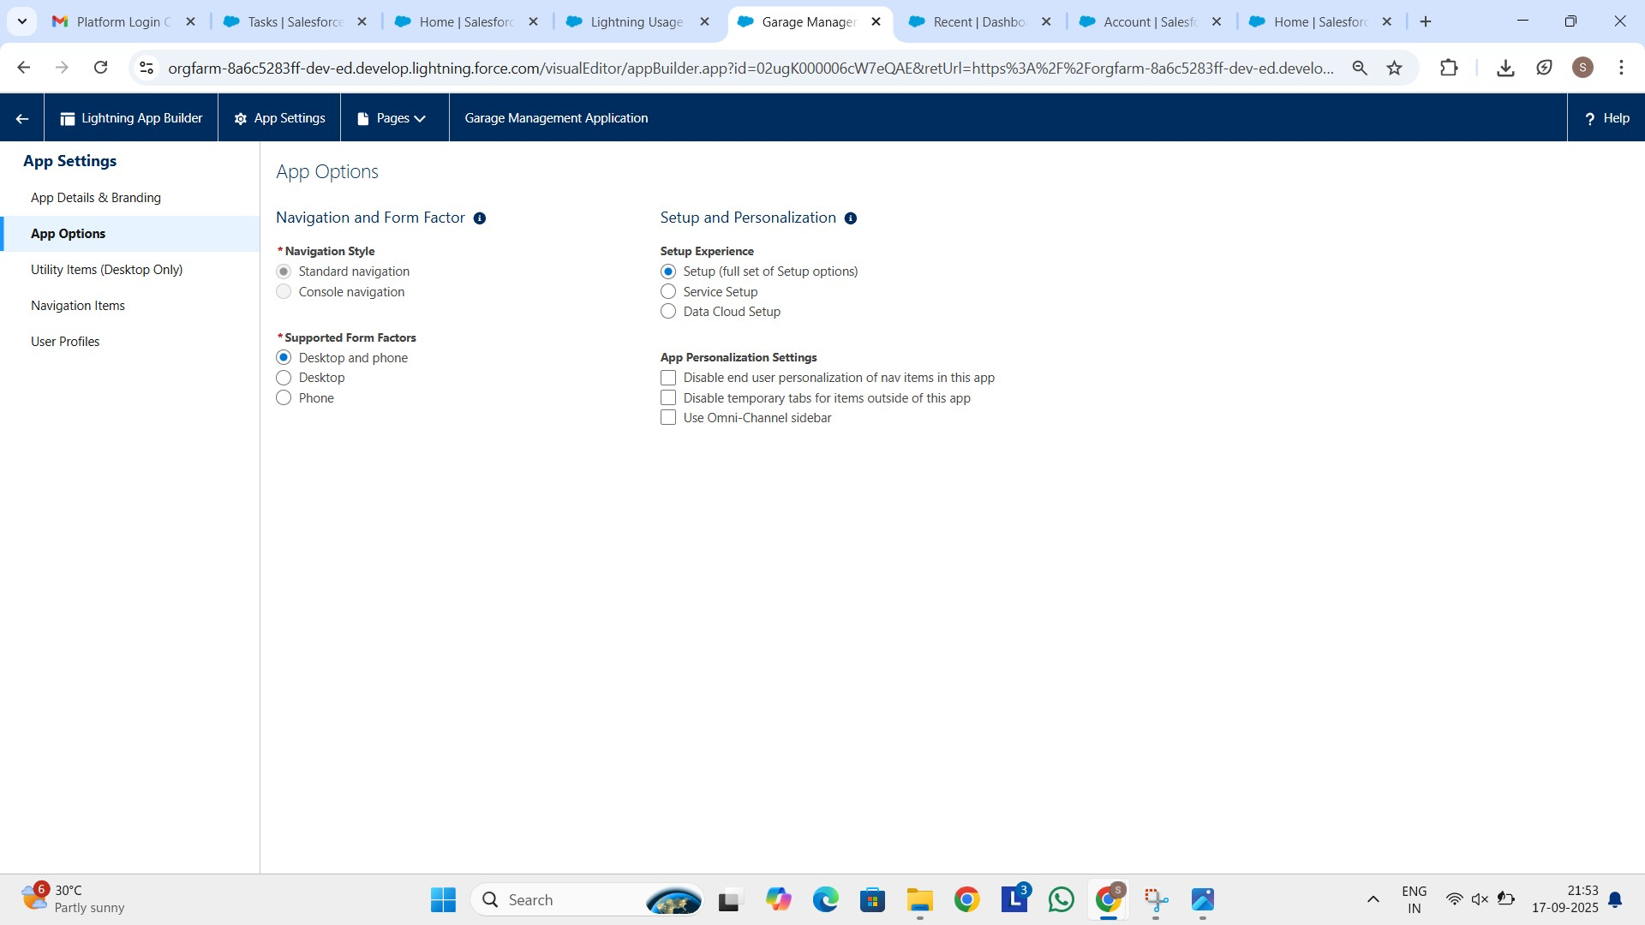

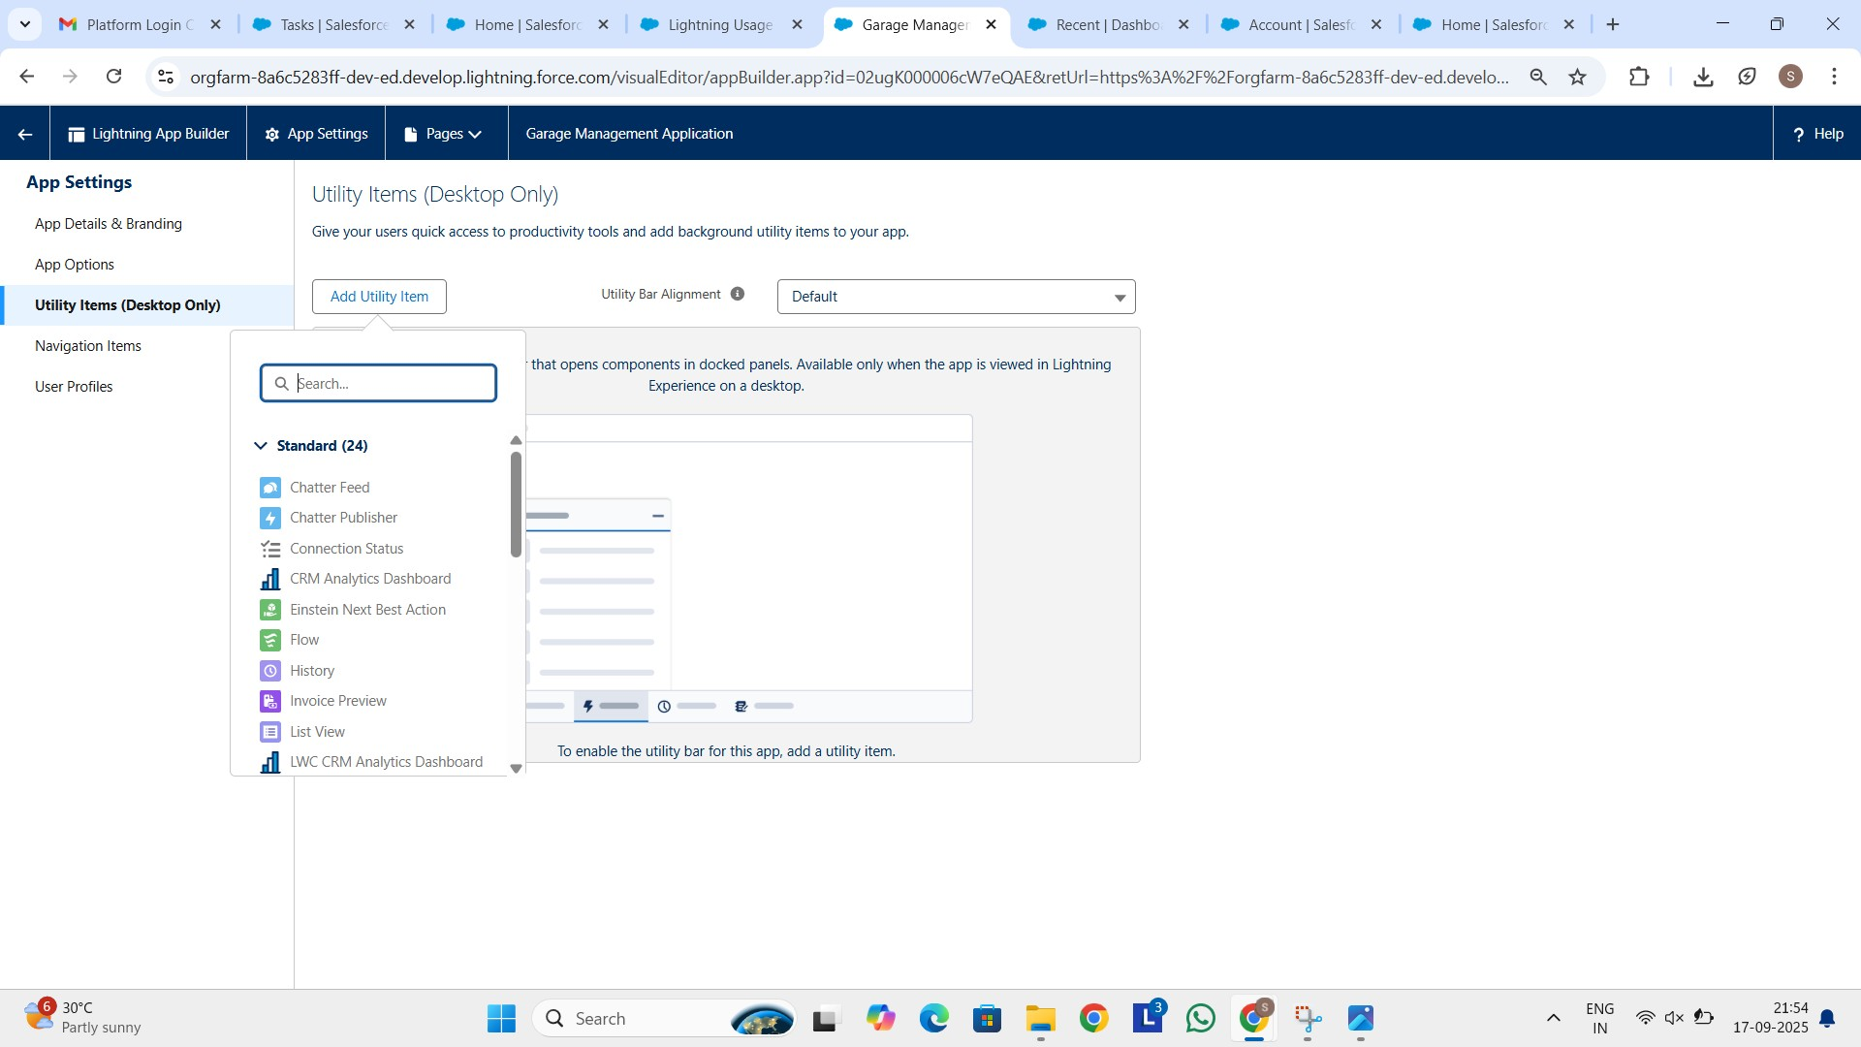

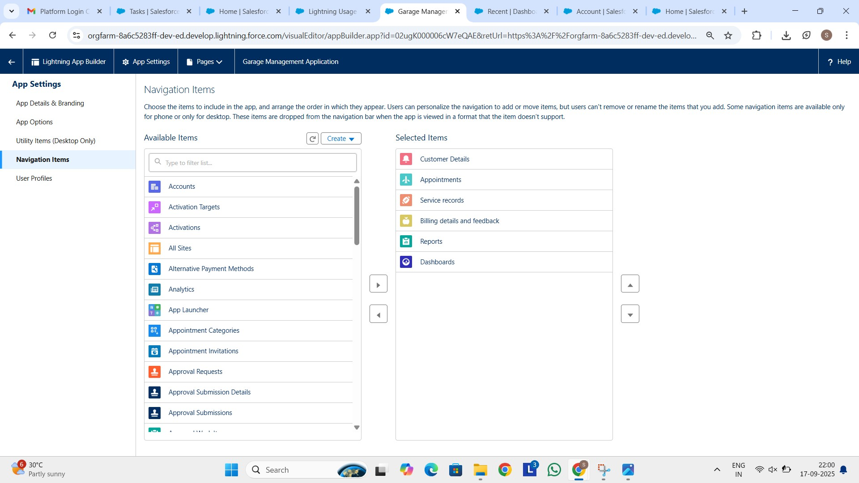

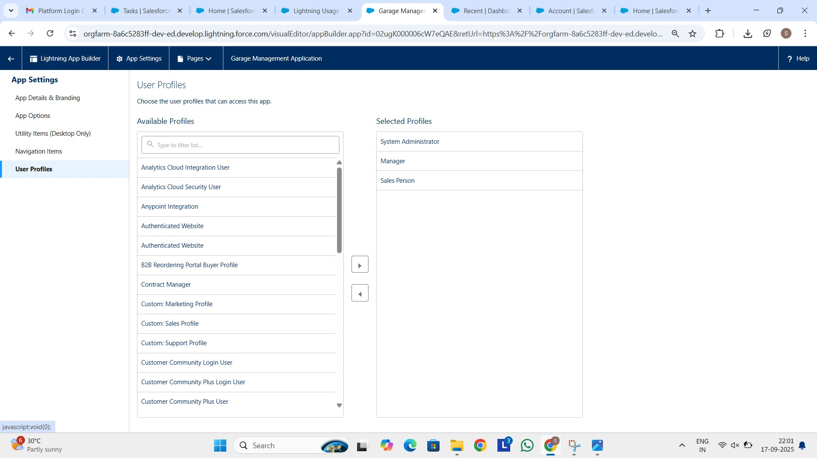

Implemented flow for billing details and feedback:

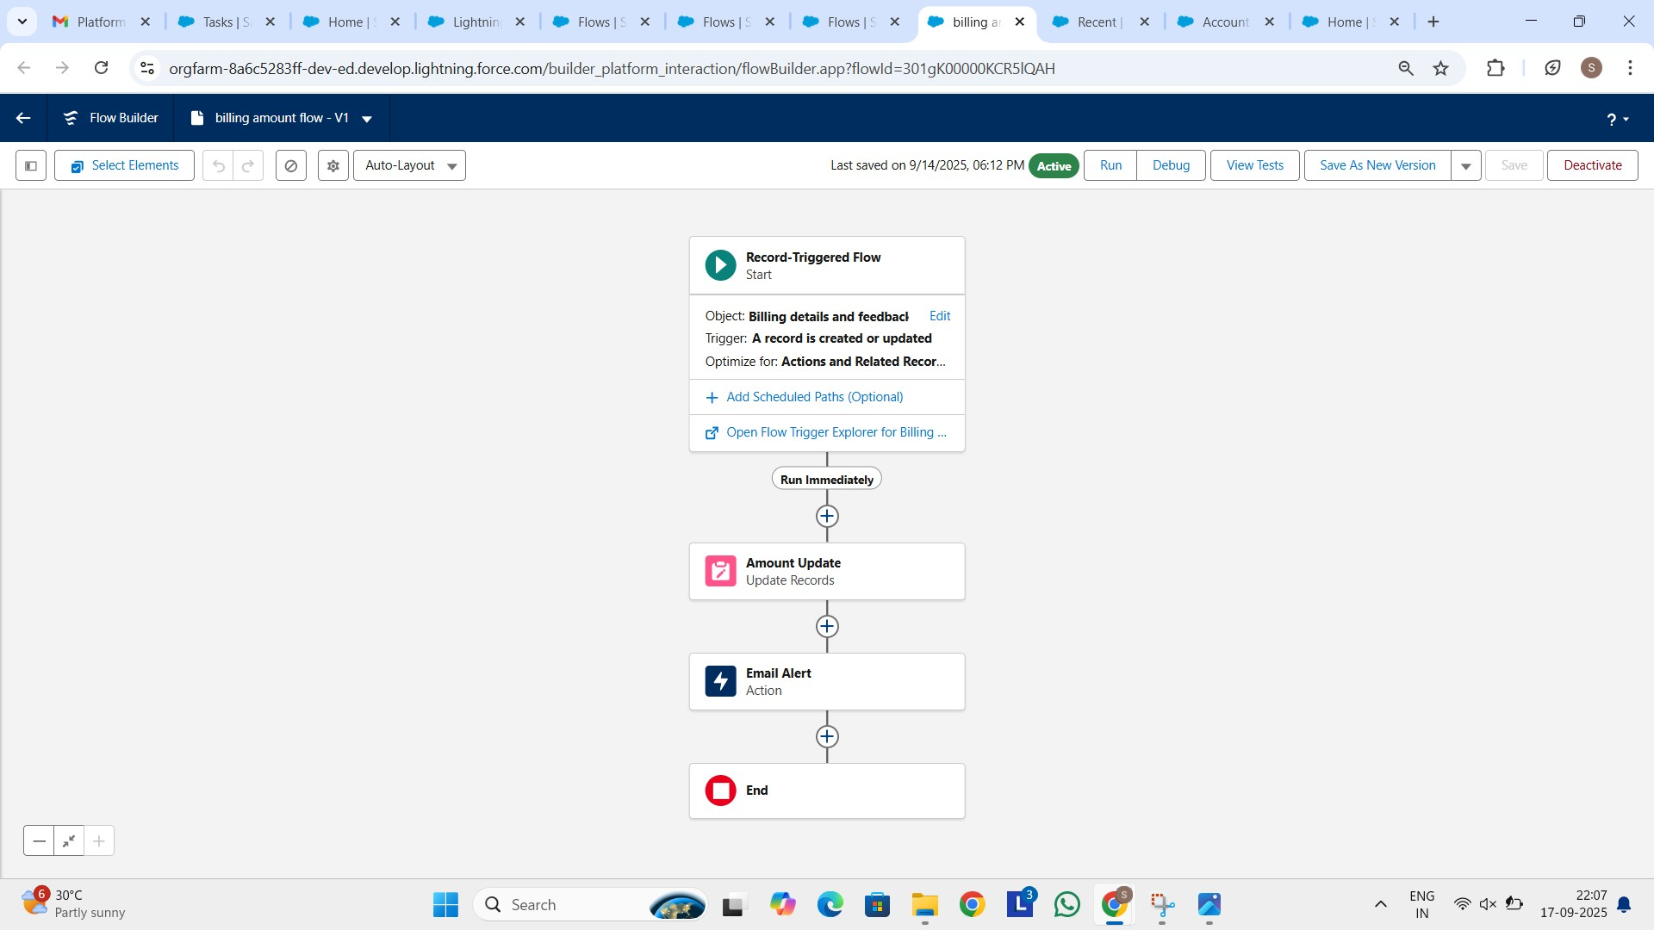

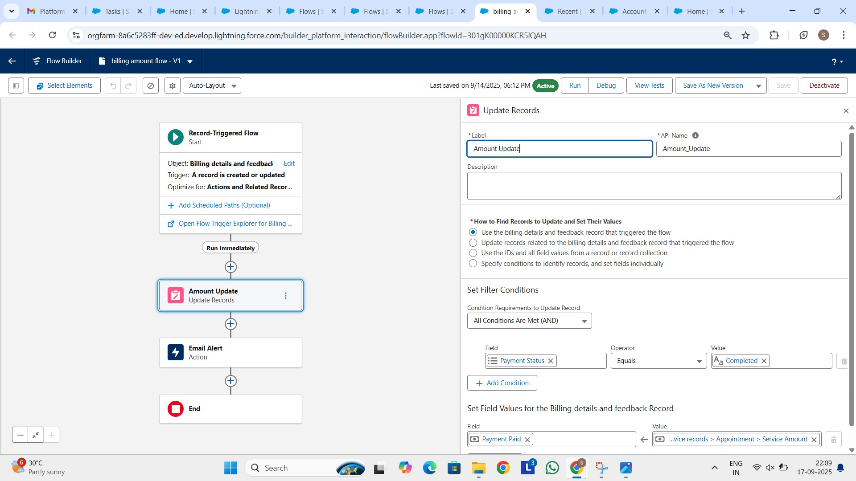

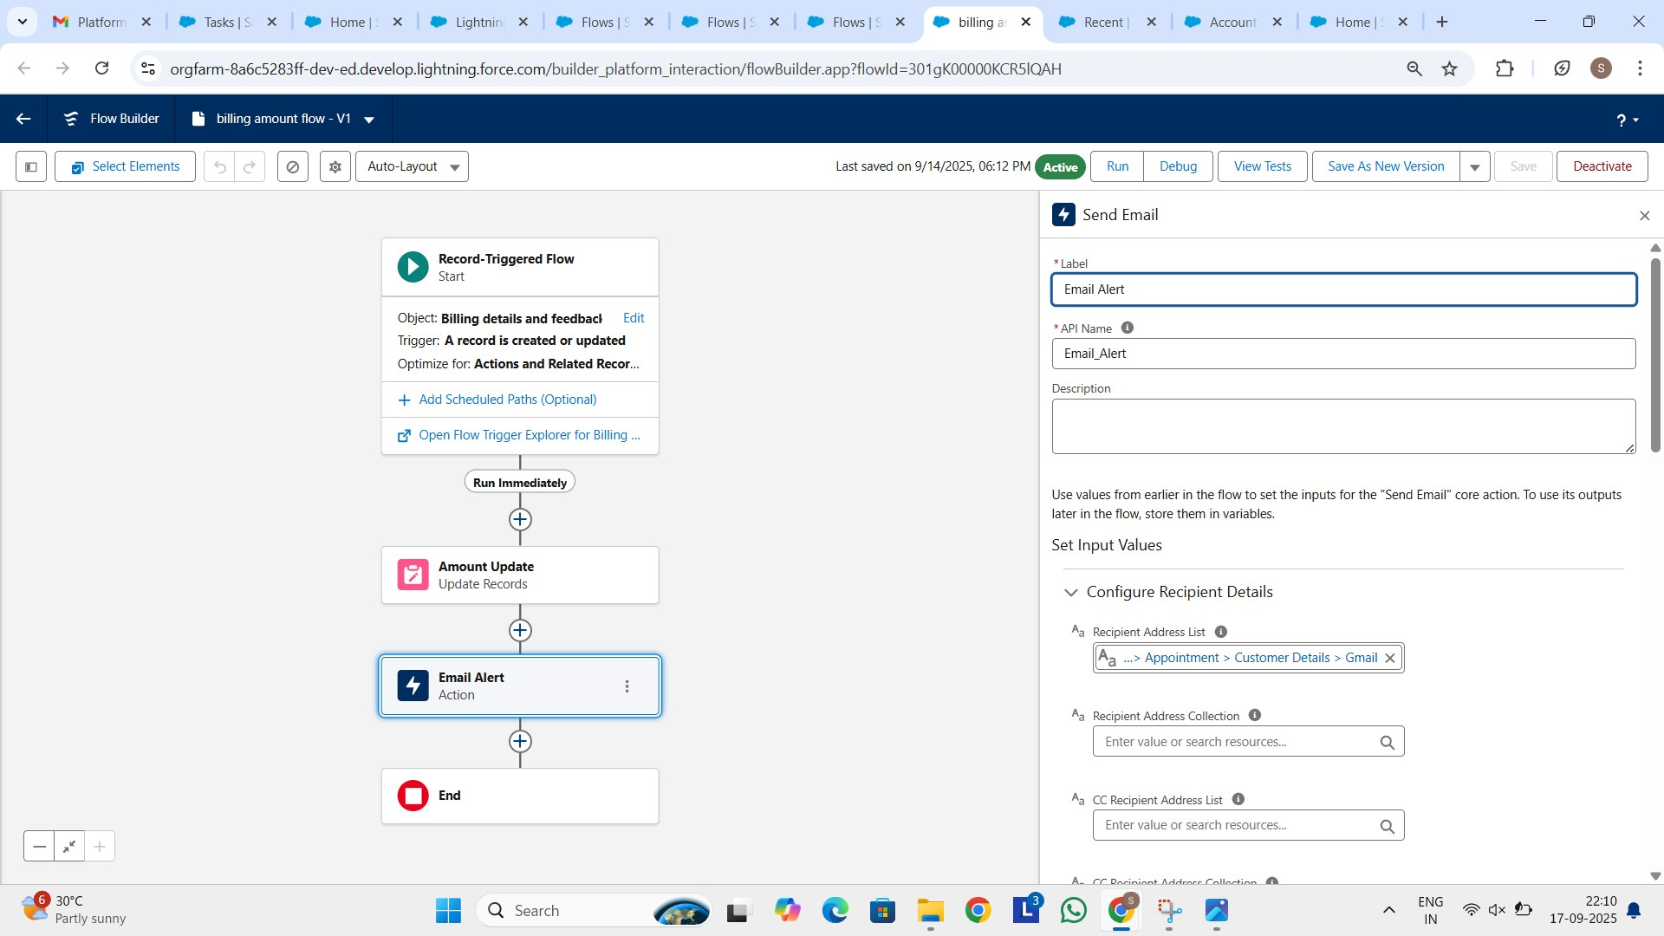

Created Apex Class:

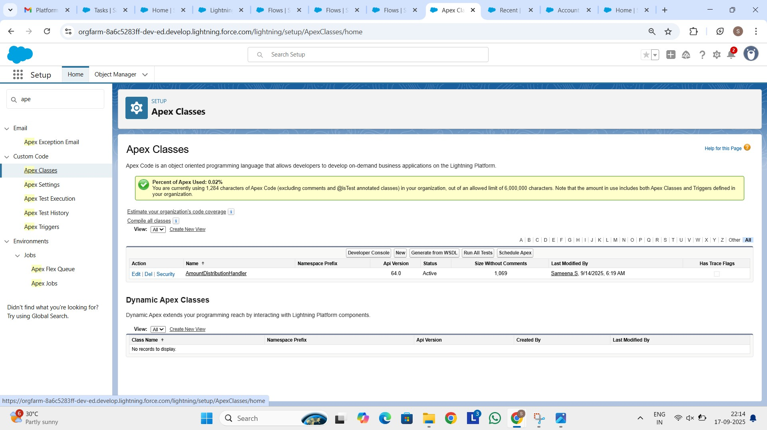

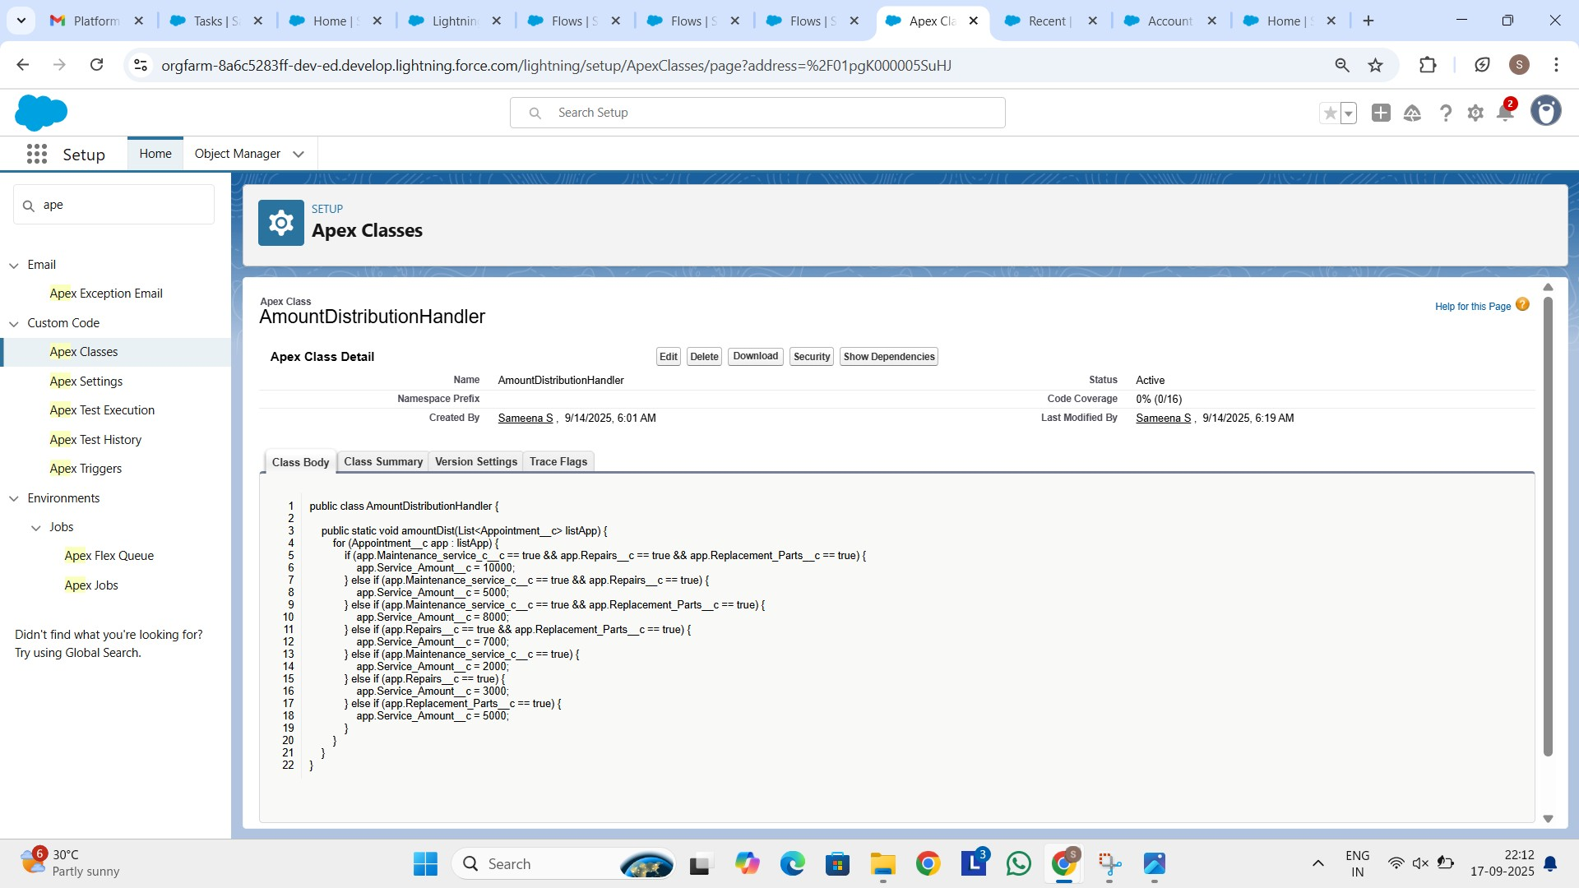

Created Triggers:

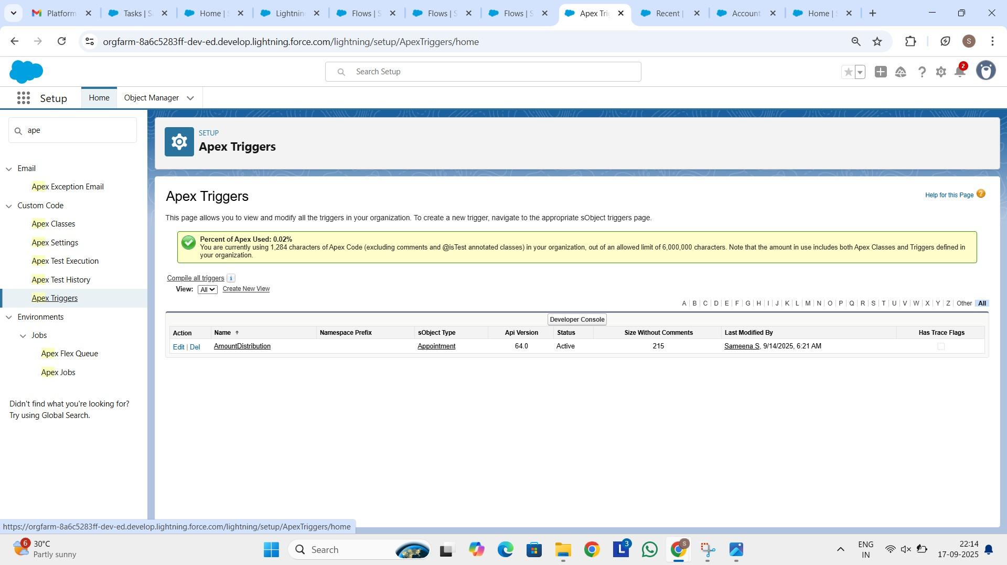

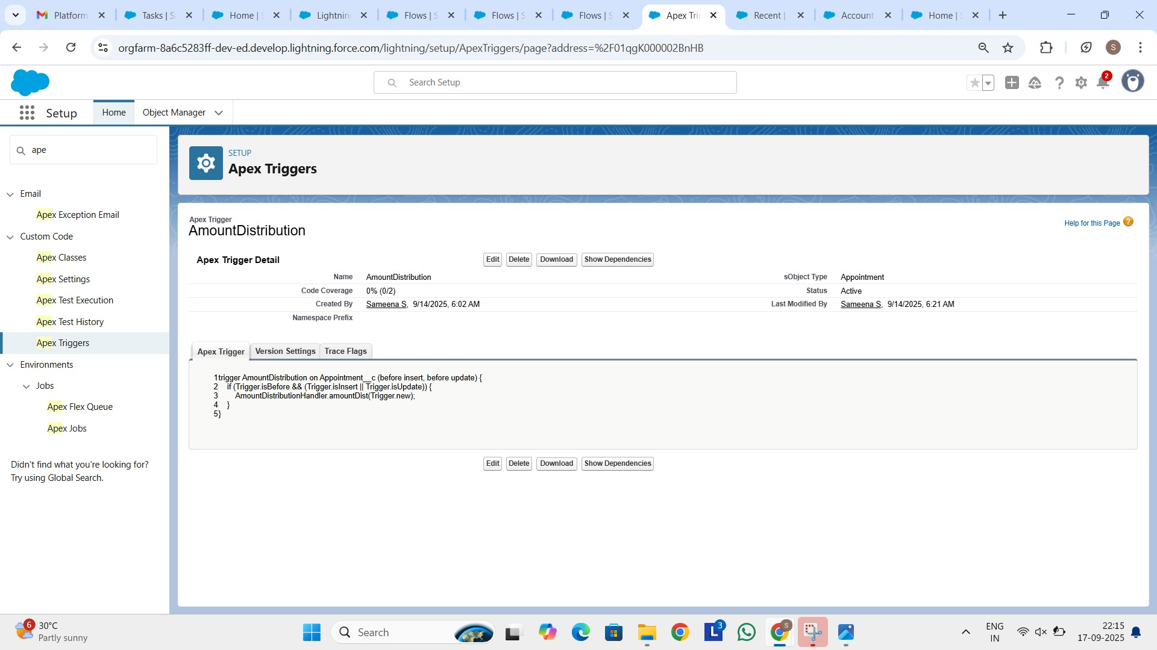

Created Public Groups:

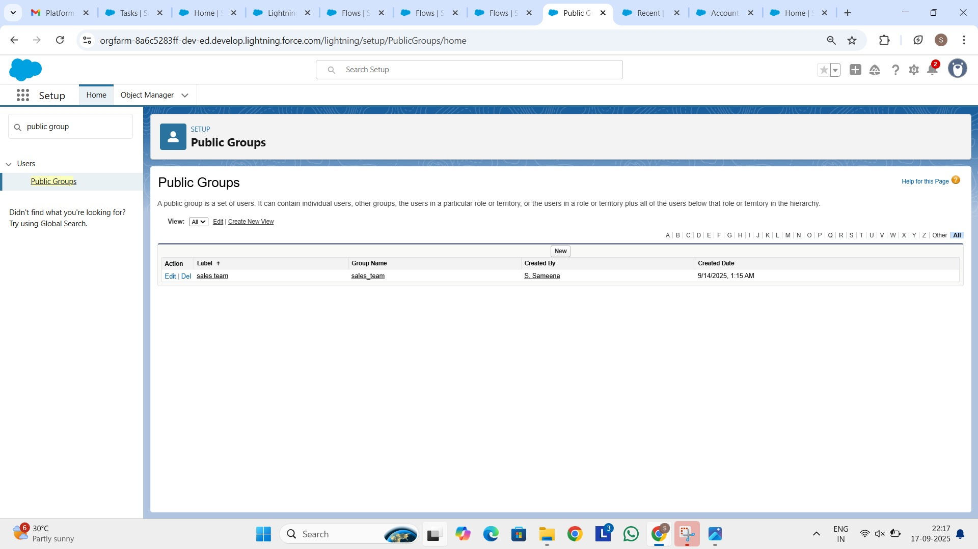

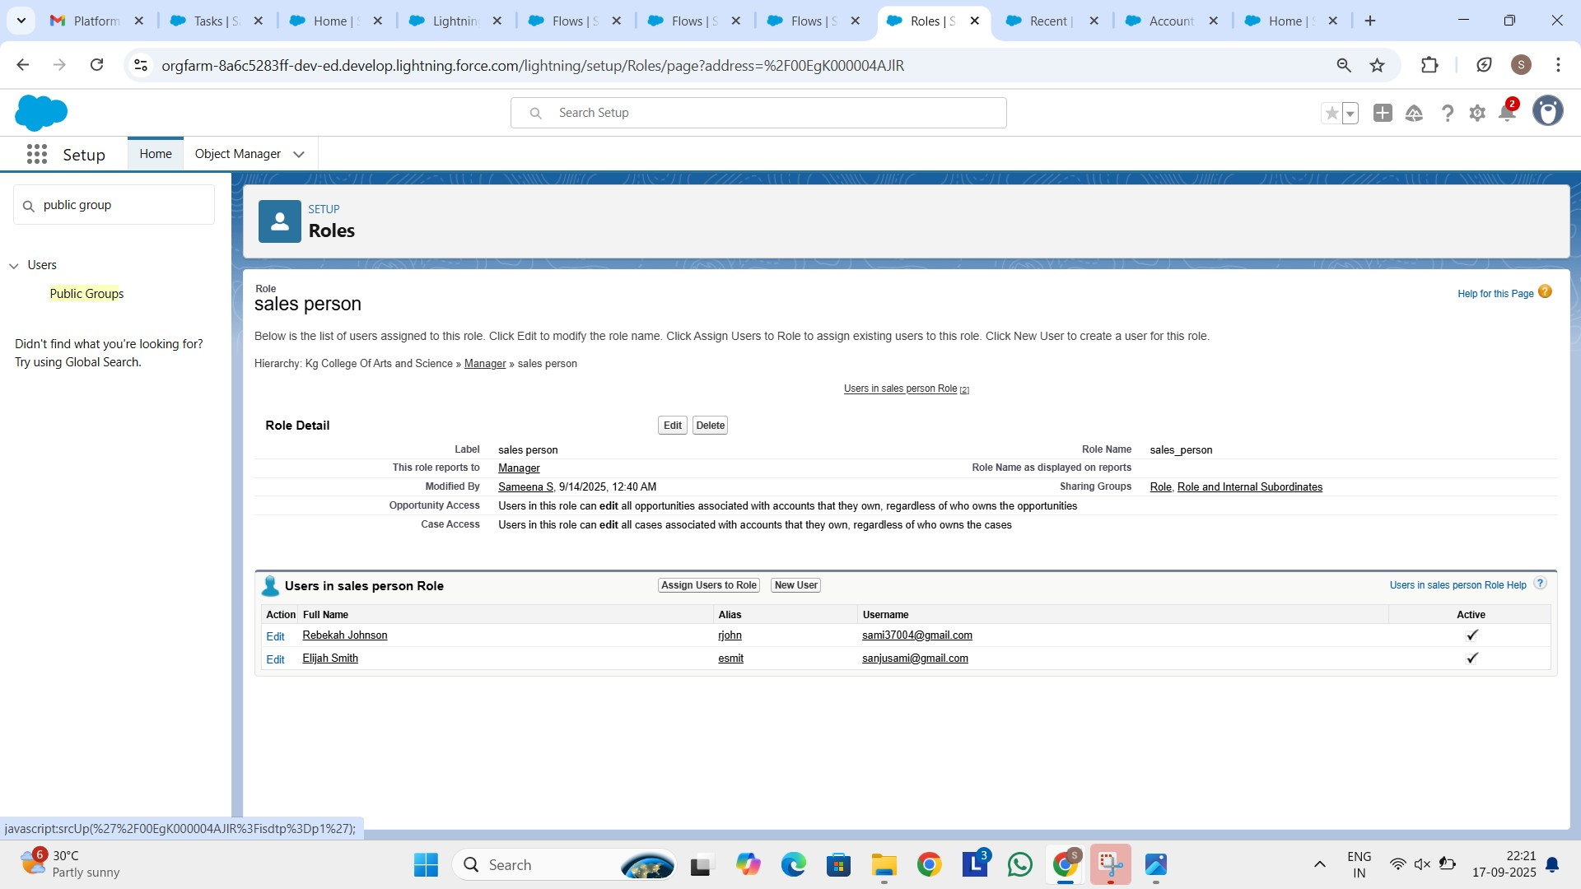

Custom Report Types:

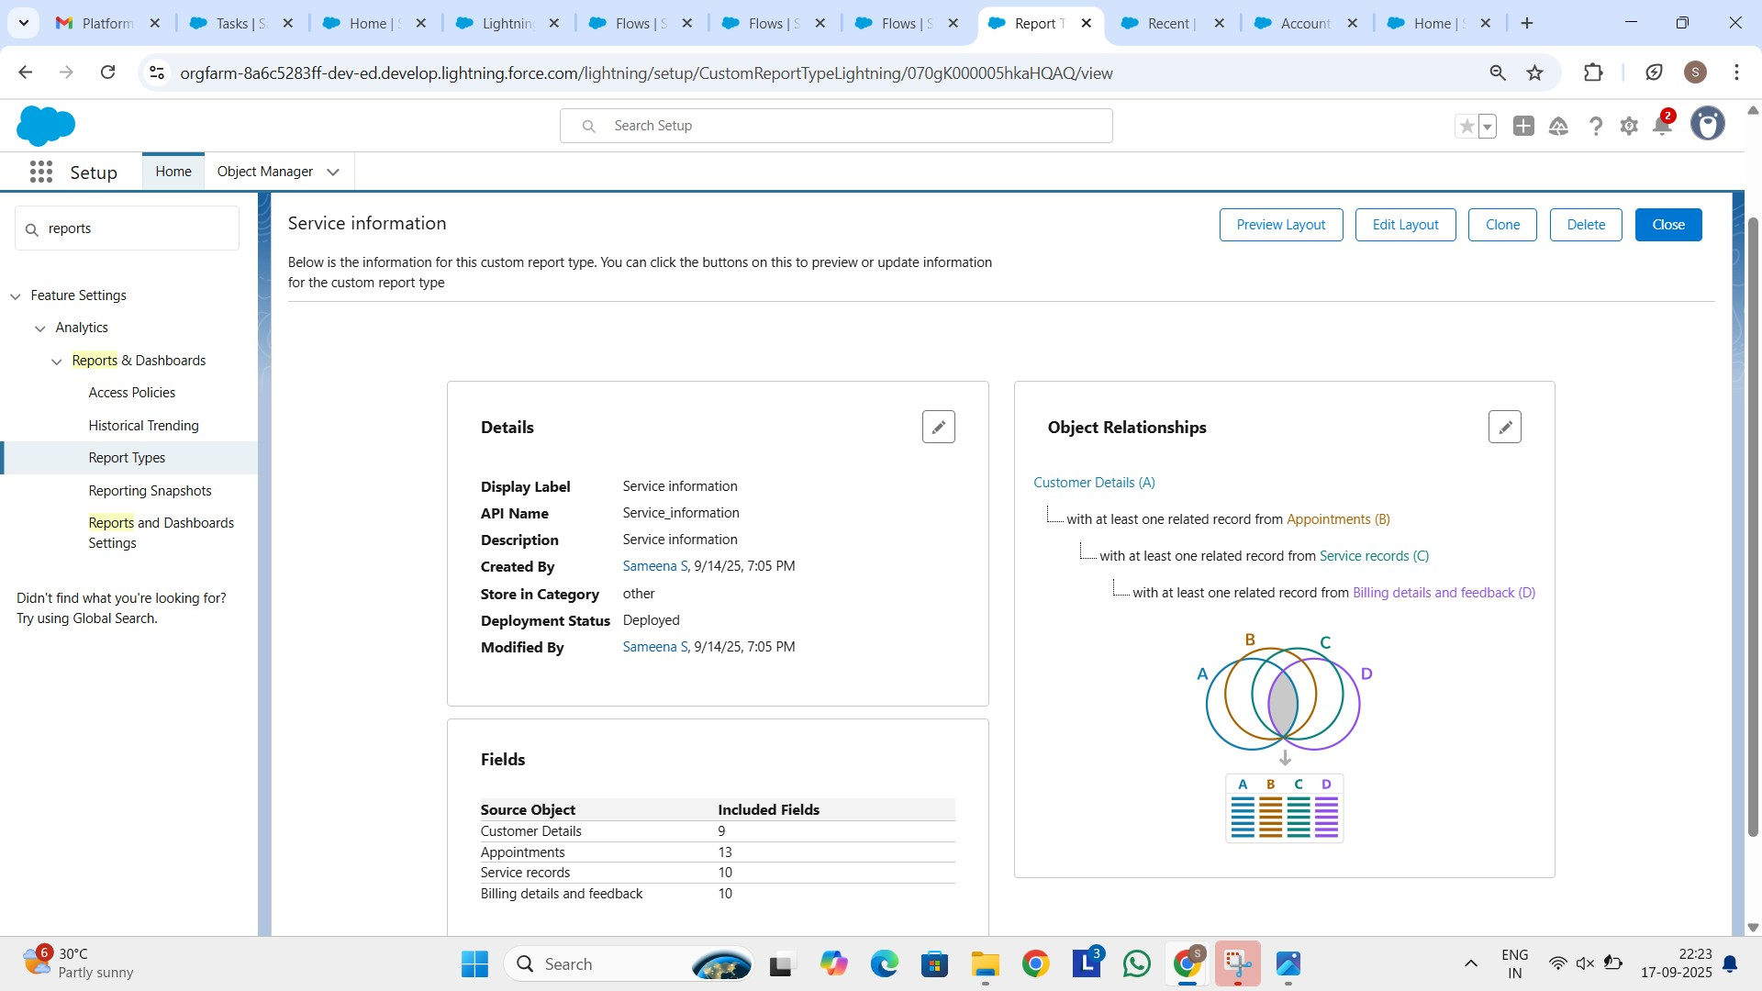

Dashboard:

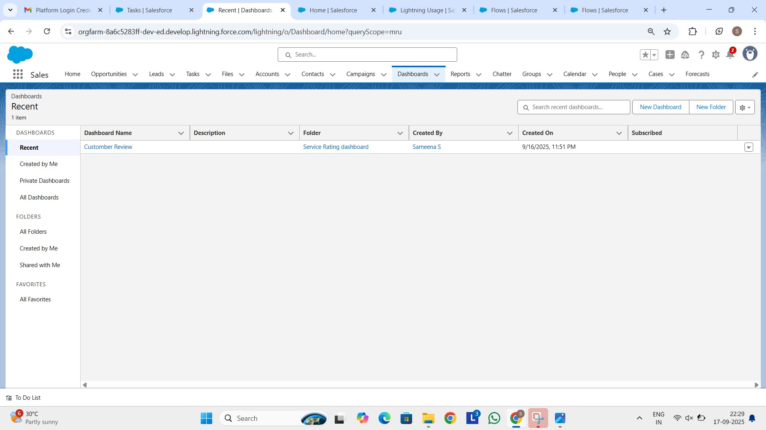

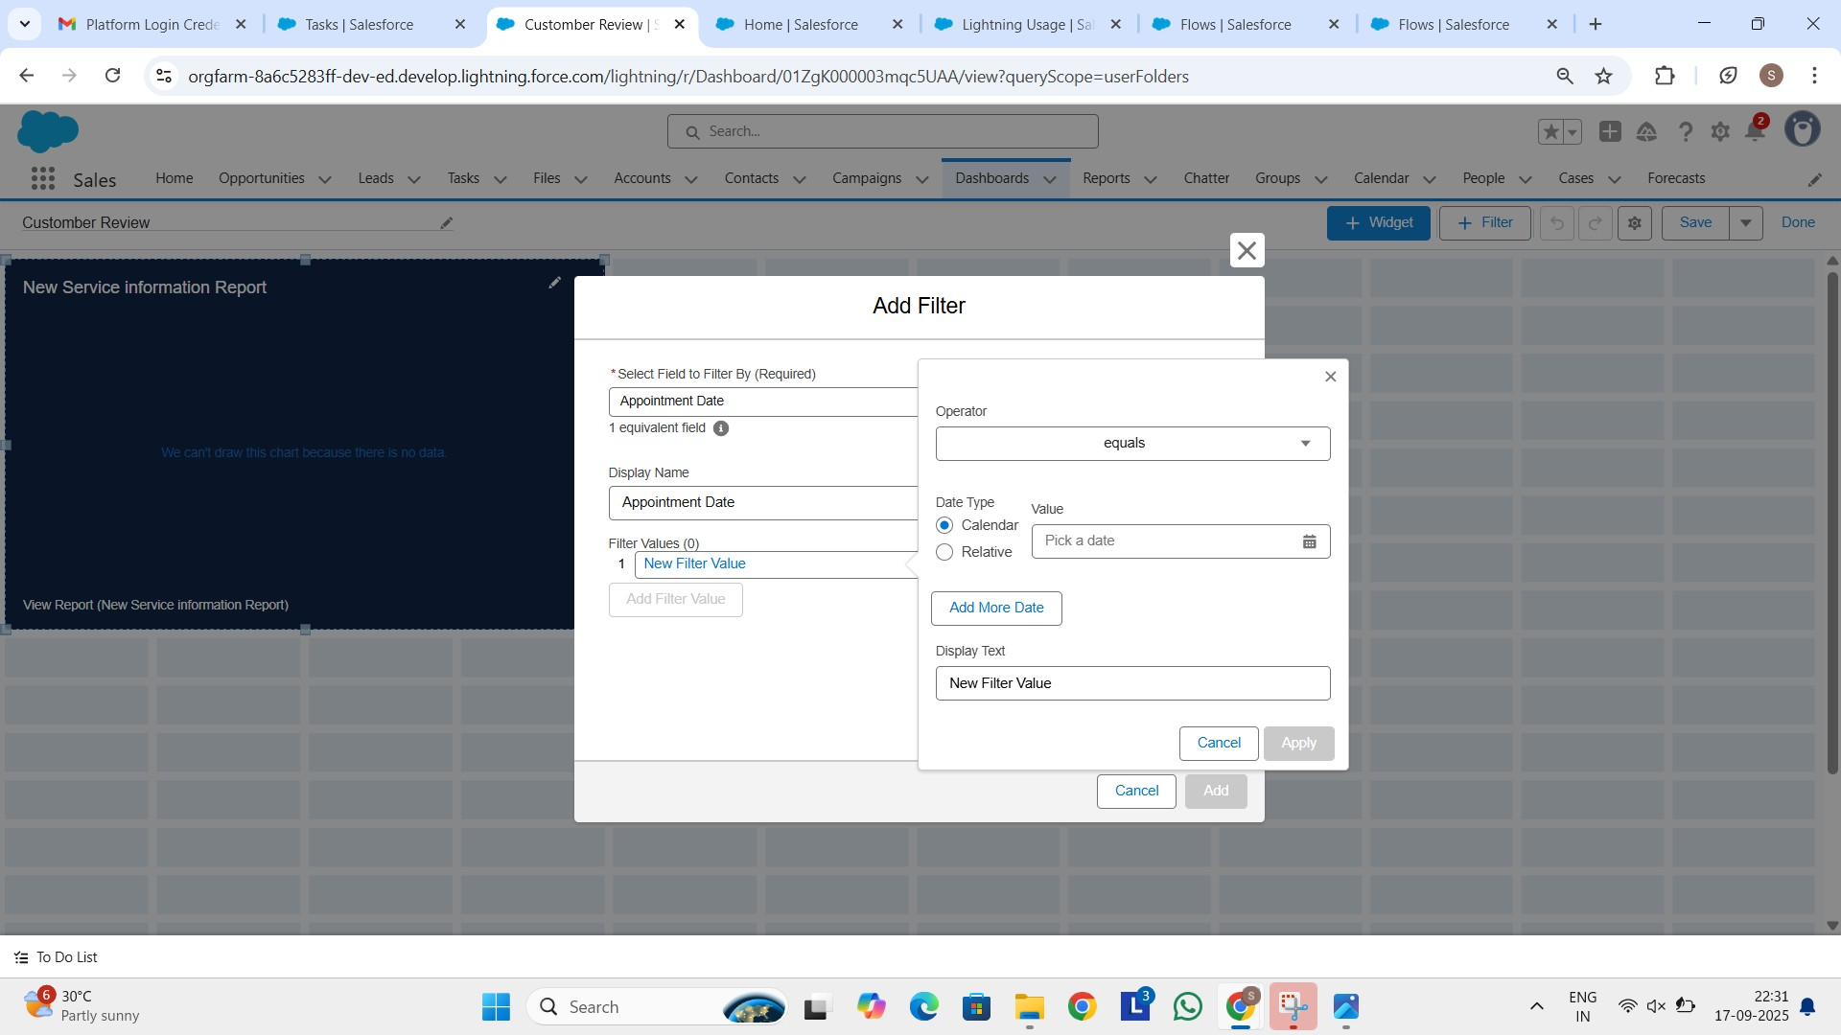

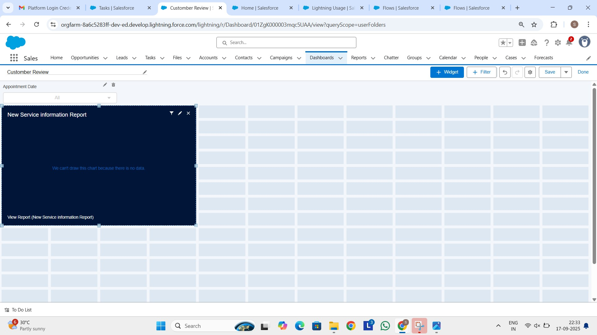

**Advantages:**

**Improved Efficiency:**

Automates job cards, billing, and inventory, reducing manual workload.

**Better Customer Service:**

Stores service history, sends reminders, and ensures timely updates.

**Accurate Billing:**

Reduces errors in labor charges, parts costs, and taxes.

**Inventory Control:**

Tracks spare parts availability and prevents stockouts or overstocking.

**Data Management & Reporting:**

Provides detailed reports on jobs, revenue, and performance.

**Disadvantages:**

**Initial Setup Cost:**

Purchasing or developing the system can be expensive.

**System Dependency:**

Heavy reliance on the software may cause disruptions if technical issues occur.

**Maintenance & Updates:**

Requires regular software updates and possible IT support.

**Data Security Risks:**

Sensitive customer and financial data must be properly secured.

**Internet/Power Dependency:**

Cloud-based or online systems may face downtime without connectivity.

**Conclusion:**

The Garage Management System (GMS) plays a vital role in modernizing and streamlining the operations of automotive repair facilities. By automating job scheduling, inventory tracking, billing, and customer communication, it enhances efficiency, accuracy, and service quality. While the system may require initial investment, training, and ongoing maintenance, the long-term benefits—such as improved customer satisfaction, optimized resource management, and increased profitability—far outweigh the challenges. Overall, GMS provides a reliable and effective solution for garages to stay competitive in the rapidly evolving automotive service industry.

**Appendix:**

**Source code**: Apex class and triggers

**Apex classes**: AmountDistributionHandler

public class AmountDistributionHandler {

public static void amountDist(List<Appointment__c> listApp) { for (Appointment__c app : listApp) { if (app.Maintenance_service_c__c == true && app.Repairs__c == true && app.Replacement_Parts__c == true) { app.Service_Amount__c = 10000;

} else if (app.Maintenance_service_c__c == true && app.Repairs__c == true) { app.Service_Amount__c = 5000;

} else if (app.Maintenance_service_c__c == true && app.Replacement_Parts__c == true) { app.Service_Amount__c = 8000;

} else if (app.Repairs__c == true && app.Replacement_Parts__c

== true) { app.Service_Amount__c = 7000;

} else if (app.Maintenance_service_c__c == true) { app.Service_Amount__c = 2000; } else if (app.Repairs__c == true) { app.Service_Amount__c = 3000;

} else if (app.Replacement_Parts__c == true) { app.Service_Amount__c = 5000;

}

}

}

}

**Apex Triggers:** AmountDistribution

trigger AmountDistribution on Appointment__c (before insert, before update) {

if (Trigger.isBefore && (Trigger.isInsert || Trigger.isUpdate)) {

AmountDistributionHandler.amountDist(Trigger.new);

}

}